Accessibility Style Guide
Table of Contents

Overview ………………………………………………………………………………………. 1
Tools and Resources ……………………………………………………………………….. 2

1. Page Structure …………………………………………………………………………….. 3
Page Title ………………………………………………………………………………. 3
Headings ……………………………………………………………………………….. 3
Lists …………………………………………………………………………………….. 3

2. Visual Accessibility ………………………………………………………………………. 4
Fonts ……………………………………………………………………………………. 4
Link Text ……………………………………………………………………………….. 4
Images: DOM or CSS? ……………………………………………………………….. 4
Text Alternatives for Images …………………………………………………………. 4
Multimedia Content …………………………………………………………………… 5
Electronic Documents ………………………………………………………………… 5
PDF Documents ………………………………………………………………………. 5
Forms …………………………………………………………………………………… 5

3. Keyboard Accessibility ………………………………………………………………….. 7
Focus Indicators ………………………………………………………………………. 7
Navigation Order ……………………………………………………………………… 7
Items That Can't Receive Keyboard Focus ………………………………………... 8
Custom Widgets ………………………………………………………………………. 8

4. Dynamic Content …………………………………………………………………………. 9
Overview of Dynamic Content ………………………………………………………. 9

5. Aria-Label Guidelines ………………………………………………………………….. 10
Overview of Aria-Label ……………………………………………………………… 10
Aria-Label in Links …………………………………………………………………… 10
Semantic Elements ………………………………………………………………….. 11
Aria Roles …………………………………………………………………………….. 11
Common Aria Role Types …………………………………………………………... 12
Using Aria-Hidden …………………………………………………………………… 13

6. Responsive Design and Accessibility ………………………………………………. 14
Design Topics to Consider ………………………………………………………….. 14
Fluid Grids ……………………………………………………………………………. 14

Overview
Web Content should be accessible to all. At minimum, features should comply to the requirements listed in 508 Reference Guide - 1194.22 from the US Access Board, and conform to Web Content Accessibility Guidelines 2.0 and WCAG 2.1 at Level AA.
Making the web accessible benefits everyone, not just people with disabilities. Below are some examples of use cases in which accessibility is important:
- Visual: blindness, low vision, color blindness, using a screen reader or related assistive tech for lifestyle reasons (e.g. long car commute), machine readability and screen scraping technologies
- Hearing: deafness, hearing impairment, speech impairment, using closed captioning or other assistive features for lifestyle reasons (e.g. coworking in a loud coffee shop)
- Cognitive: including short-term memory issues, dyslexia, learning disabilities, trying to work or consume content while distracted or multitasking, etc.
- Mobility: mobility impairments, repetitive stress injuries, power users who love keyboard shortcuts, busy parents holding a sleeping child while trying to operate a computer with one hand, etc.

Tools and Resources

Web Accessibility Checklist https://www.dor.ca.gov/Content/DorIncludes/documents/Ab434/Web-Accessibility-Checklist_2.12_080919.docx

Web Accessibility Evaluation Tools
https://www.w3.org/WAI/ER/tools/
https://webaccess.msu.edu/Help_and_Resources/evaluation-validation.html

Monitoring Accessibility with persistence
https://webaim.org/articles/implementation/monitor

Articles on Accessibility
https://webaim.org/articles/

Accessibility and UX Design Aesthetic Balance
https://uxmovement.com/thinking/the-aesthetic-accessibility-paradox/

1) Page Structure

PAGE TITLE
For each web page, provide a short title that describes the page content and distinguishes it from other pages. The page title is often the same as the main heading of the page.

Put the unique and most relevant information first. For example, put the name of the page before the name of the organization. For pages that are part of a multi-step process, include the current step in the page title.

HEADINGS
Use short headings to group related paragraphs and clearly describe the sections. Good headings provide an outline of the content.

Rules for Headings:
- Every page must have an H1
- H tags should be nested properly from H1, H2, H3, etc.
- Check in the code to verify proper nesting. Or check with the Elements List for Headers in NVDA Screen Reader.

LISTS
HTML lists (<ul>, <ol>, and <dl>) also convey a hierarchical content structure. Lists should never be used for merely indenting or other layout purposes.

As with heading, lists should be used correctly and for the right purposes. Unordered and ordered lists should always contain list items. Definition lists must always have definition descriptions.

2) Visual Accessibility

FONTS
Be mindful when using small font size, thin font weight, low contrast colors in designs as it can severely affect usability.
Instead of relying solely on color to communicate information, always combine color with another factor, like shape or position change. This is important because some colors can be hard to tell apart due to color blindness or weak eyesight.
More on visual accessibility:
- Use of Color – Understanding WCAG 2.0
- Contrast – Understanding WCAG 2.0

LINK TEXT
Write link text so that it describes the content of the link target. Avoid using ambiguous link text, such as ‘click here’ or ‘read more’. Indicate relevant information about the link target, such as document type and size, for example, ‘Proposal Documents (RTF, 20MB)’.

Wrong: “For more information, click here.”
Right: “Read more about this specific topic.”

IMAGES: DOM or CSS?
When it comes to using and including images in your document, where's the best place to put them? The easy answer is: If the image provides context or meaning, it should be in the DOM.
If the images are purely decorative, they can be shown using CSS. If a decorative image is being used in the markup, be sure and use an empty alt attribute (alt="") so it's not announced.

TEXT ALTERNATIVES FOR IMAGES
For every image, write alternative text that provides the information or function of the image. For purely decorative images, there is no need to write alternative text.

MULTIMEDIA CONTENT
For audio-only content, such a podcast, provide a transcript. For audio and visual content, such as training videos, also provide captions. Include in the transcripts and captions the spoken information and sounds that are important for understanding the content, for example, “Door creaks.” For video transcripts, also include a description of the important visual content, for example, “Ethan leaves the room.”

Voice recognition software can help create captions for some type of videos. Sometimes such voice recognition software is built into the computer or social media platform. Automatically-generated captions often need editing. For many languages there are captioning services, often also remote services.

ELECTRONIC DOCUMENTS
Baseline accessibility requirements for all electronic documents:

- Document file name should not contain any spaces or special characters.
- Document file name needs to be concise, generally limited to 20-30 characters and should clarify the contents of the file.
- All Document properties should be filled out: Title, Author, (an HHS OpDiv, StaffDiv, or Program Office---not an individual’s names) Subject, and Keywords
- Use electronic version for any signatures.

PDF DOCUMENTS
When creating new PDFs, follow Adobe guidelines to make PDFs accessibility. For existing PDFs, check accessibility:
- Choose Tools > Accessibility.
- In the secondary toolbar, click Full Check.
- In the Report Options section, select options for how you want to view the results.
- Select a page range.
- Select one or more of the Checking Options.
- Click Start Checking.

FORMS
It is common for assistive technology users to jump straight to a form when using a website, so make sure most relevant information is in the form and is labelled properly. Labels and inputs should be associated with the label[for] and input[id], and help texts should either be part of the label or be associated with aria-describedby.

Three general guidelines for accessible forms:
- Ensure forms are logical and easy to use. Instructions, cues, and required form fields should be clearly identified.
- Ensure forms are keyboard accessible.
- Associate form labels with controls. The <label> element is used to associate a text label to a form control. This allows a screen reader to read the associated label text when the user navigates to the form control.

3) Keyboard Accessibility

Keyboard accessibility is one of the most important aspects of web accessibility. Many users with motor disabilities rely on a keyboard. Blind users also typically use a keyboard for navigation. In addition to traditional keyboards, some users may use modified keyboards or other hardware that mimics the functionality of a keyboard.

FOCUS INDICATORS
A keyboard user typically uses the Tab key to navigate through interactive elements on a web page—links, buttons, fields for inputting text, etc. When an item has keyboard "focus", it can be activated or manipulated with the keyboard. A sighted keyboard user must be provided with a visual indicator of the element that currently has keyboard focus. A basic focus indicator is provided automatically by the web browser and is typically shown as a border (called an outline) around the focused element. However, these outlines can be hidden by applying outline:0 or outline:none CSS to focusable elements.

In addition to the default outline, you can use CSS to make the focus indicator more visually apparent and keyboard-friendly by adding a background color or other visual style to links, and other controls that will receive keyboard focus. The outline can be styled to match your site design.

NAVIGATION ORDER
As a keyboard user navigates through the page, the order in which interactive items receive keyboard focus is important. The default keyboard navigation order must be logical and intuitive. This generally means that it follows the visual flow of the page: left to right, top to bottom - header first, then main navigation, then page navigation (if present), and finally the footer. This navigation order (and also the reading order for screen readers) is determined by the web page's source code. For best results:
- Structure your underlying source code so that the reading/navigation order is correct.
- Then, if necessary, use CSS to control the visual presentation of the elements on your page.
- Do not use tabindex values of 1 or greater to change the default keyboard navigation order.

ITEMS THAT CAN’T RECEIVE KEYBOARD FOCUS
By default, users can only navigate to links, buttons, and form controls with a keyboard. These natively-accessible elements should be used whenever possible. If this is not possible, you may need to use tabindex="0" to ensure an element can receive keyboard focus.

Note: An <a> element is only keyboard accessible or presented to screen reader users as a link when it has a non-empty href attribute. <a> (without an href attribute) or <a href=""> (no href attribute value) should not be used for links.

CUSTOM WIDGETS
Although elements that are natively keyboard accessible should be used when possible, there are times when HTML falls short and custom "widgets" are necessary. Complex menus, sliders, dialogs, tab panels, etc. must all be built to support keyboard accessibility. This means the following must occur:
- The interaction is presented in an intuitive and predictable way
- JavaScript event handlers work with a keyboard and a mouse.
- The interaction uses standardized keystrokes.

Source: https://webaim.org/techniques/keyboard/

4) Dynamic Content

OVERVIEW OF DYNAMIC CONTENT
When content updates dynamically (i.e. without a page refresh), screen readers may not be aware. This includes screen overlays, lightboxes, in-page updates, popups, and modal dialogs. Keyboard-only users may be trapped in page overlays. Magnification software users might be zoomed in on the wrong section of the page.

These functions can easily be made accessible. Options include ARIA roles and alerts, as well as front-end development frameworks that specifically support accessibility.
Ensure that video players do not auto-play (non-consensual sound), and that the players can be used with a keyboard. Additionally, all videos must have options for closed captioning and transcripts for the hearing-impaired.

If your site contains a slideshow, make sure that each photo has alt text and can be navigated via the keyboard. If you are using any unique widgets (such as a calendar picker or drag-and-drops), be sure to test for accessibility.

Source: https://webaccess.berkeley.edu/resources/tips/web-accessibility#accessible-dynamic

5) Aria-Label Guidelines

OVERVIEW OF ARIA-LABEL
Use Aria-label when a text label is not visible on the screen. If there is visible text labeling the element, use the aria-labelledby attribute instead.

This attribute can be used with any typical HTML element; it is not limited to elements that have an ARIA role assigned.

NOTE: Most modern browsers implement the accessibility features outlined in the specs for these elements; without them, elements will need additional ARIA attributes and roles to be recognized by assistive technologies. Elements like h1-h6, nav, footer, header have meaningful roles assigned, so use them, and use them carefully. This can help assistive technologies read the page better and help users find information quicker. Only use a div or a span to markup up content when there isn't another HTML element that would semantically be more appropriate, or when an element is needed exclusively for applying CSS styles or JS behaviors.

ARIA-LABEL IN LINKS
A link should generally speak for itself, but if you don’t have understandable text for a link, use an aria-label to give the link more meaning.

Example 1:

Before: For more information about us, <a href="/about">click here</a>
After: For more information about us, <a href="/about" aria-label="about us">click here</a>

Example 2:
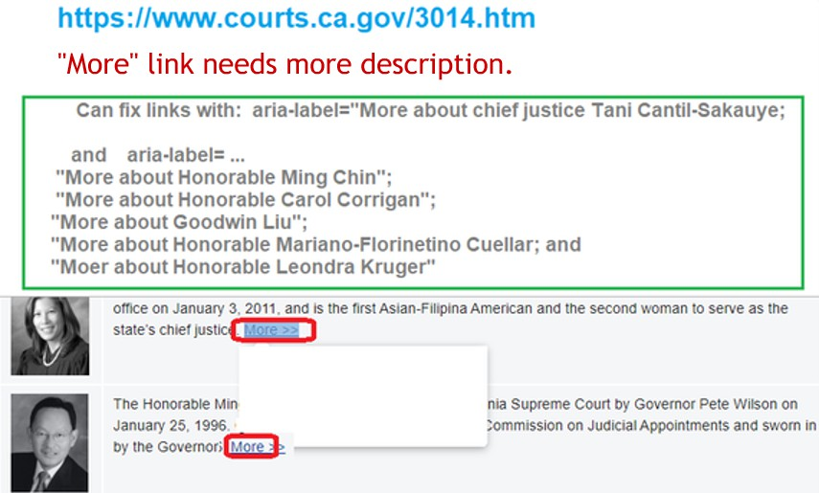

SEMANTIC ELEMENTS
For low-sighted users who navigate pages by jumping to the desired page section:
- Use sectioning elements to create a broad outline of your page content; examples of these elements include header, nav, main, and footer. Use content sectioning elements like section, article, and aside to organize the document content into logical pieces.
- Add role="banner" to your masthead and role="contentinfo" to your page footer once per page to define landmark elements.

ARIA ROLES
An ARIA role is added via a role="<ROLE TYPE>" attribute and does not change for an element once set. There are six categories of ARIA roles:
- Landmark
Landmark roles identify large content areas and are used by screen readers for navigation. Ideally all content of a document would be placed within a landmark role. Doing so would ensure that all content could be navigated to by use of landmarks. E.g. <footer role="contentinfo">.
- Document Structure
Document Structure roles provide a structural description for a section and are typically non-interactive. Some document roles map onto existing HTML tags (E.g. role="form") and are only meant for cases when using the native tag is not possible, or to bridge gaps in support.
- Widget
Widget roles describe common interactive patterns that currently lack semantic equivalents in HTML, and can be used on their own, or as part of larger, composite widgets. E.g. <div role="tabpanel">.
- Window
Window roles, consist of alertdialog and dialog. These roles are meant to be used when creating a sub-window to the primary document. E.g. a modal dialog.
- Live Regions
Live Region roles inherit the behavior of aria-live set to either the assertive, polite or off states. These roles should be used if a live region should promote other important role information, or be given an accessible name, beyond just producing a live announcement. E.g. <div role="alert">.
- Abstract
Abstract roles are only used by browsers to help organize and streamline a document, and never by developers to mark up HTML. Using an Abstract role in your markup would likley not produce any meaningful information.

COMMON ARIA ROLE TYPES
Common aria role types include:

- Header and Banner
The header element specifies a header for a document or section. It typically contains a heading (Level 1 to 6) for the document or section, but can also contain a table of contents, navigation, or a search field.
<header>
<!-- Stuff here -->
...
</header>
The ARIA role="banner" is used to indicate mostly site-oriented content rather than page-specific content.
<header role="banner" aria-label="Purpose of header">
<!-- Page header -->
...
</header>

- Navigation
The nav element represents a section of a page that links to other pages or to parts within the page: a section with navigation links. The nav element has an implicit ARIA role="navigation", which is used to indicate a collection of links to navigate the document or related documents.
<nav aria-label="Site">
<!-- Screen readers would announce this as "Site navigation" -->
<ul>
<!-- List items with links -->
...
</ul>
</nav>
Typical forms of navigation include site navigation, section navigation, page navigation, utility navigation, and footer navigation. The nav element usually wraps an unordered list, but doesn't have to.

- Main
The main element is used to indicate the content that relates directly to the central topic of the document.
<main aria-label="Content">
...
</main>
There

- Search
The ARIA role="search" is used to define a region where search functionality is located.
<div role="search" aria-label="Course">
...
</div>

- Complementary
The ARIA role="complementary" is used to indicate content that is complementary to the main content, yet has meaning when separated from the main content.
<div role="complementary" aria-label="References">
...
</div>

- Footer, contentinfo
The ARIA role="contentinfo" indicates a region that contains information about the parent document. It often contains information like copyright and privacy statements and usually attached to the footer. This role is automatically implied when the footer element is used.
<footer>
...
</footer>

<div role="contentinfo" aria-label="Website footer">
<!-- Copyright, privacy, terms, etc. -->
...
</div>

USING ARIA-HIDDEN
Make sure to include aria-hidden="true" with all icons. Otherwise screen readers may try to announce the icon which could confuse users. Make sure there is equivalent text that explains the icon if it's being used by itself. This text may use the .sr-only class to hide it visually if only the icon is desired.

6) Responsive Design and Accessibility

DESIGN TOPICS TO CONSIDER
The spectrum of screen sizes and resolutions is widening every day, and creating a different version of a website that targets each individual device is not a practical way forward. This is the problem that responsive web design addresses head on.

Responsive web design is not a single piece of technology, but rather a collection of techniques and ideas.

There are certain topics you need to consider when designing a site that’s both responsive and accessible. Here are some major points to consider:
- Typographic contrast
- Providing enough white space
- Columns and grids
- Navigation behavior
- Dynamic features (image sliders, videos, etc.)

All of these features must be considered when creating a responsive and accessible site. The two subjects are not directly related, but when combined they create a harmonious UI that functions well for everyone.

Source: https://www.vandelaydesign.com/accessible-responsive-web-design/

FLUID GRIDS
The first key idea behind responsive design is the usage of what’s known as a fluid grid. In recent memory, creating a ‘liquid layout’ that expands with the page hasn’t been quite as popular as creating fixed width layouts; page designs that are a fixed number of pixels across, and then centered on the page. However, when one considers the huge number of screen resolutions present in today’s market, the benefit of liquid layouts is too great to ignore.

Fluid grids go a few steps beyond the traditional liquid layout. Instead of designing a layout based on rigid pixels or arbitrary percentage values, a fluid grid is more carefully designed in terms of proportions. This way, when a layout is squeezed onto a tiny mobile device or stretched across a huge screen, all the elements in the layout will resize their widths in relation to one another.

In order to calculate the proportions for each page element, you must divide the target element by its context. Currently, the best way to do this is to first create a high fidelity mockup in a pixel based imaged editor, like Photoshop. With your high fidelity mockup in hand, you can measure a page element and divide it by the full width of the page. For example, if your layout is a typical size like 960 pixels across, then this would be your “container” value. Then, let’s say that our target element is some arbitrary value, like 300 pixels wide. If we multiply the result by 100, we get the percentage value of 31.25% which we can apply to the target element. Here’s the math:

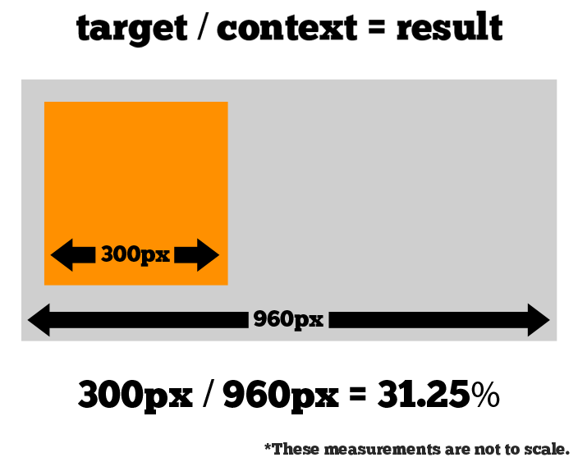

If your values don’t work out so neatly, and you get some floating point value with many numbers after the decimal, don’t round the value. Your final design will benefit from mathematical precision.

Fluid grids are a very important part of creating a responsive design, but they can only take us so far. When the width of the browser becomes too narrow, the design can start to severely break down. For example, a complex three-column layout isn’t going to work very well on a small mobile phone. Fortunately, responsive design has taken care of this problem by using media queries.

